AINT 253 Design Process (Coursework 1A)

By Dominic Reader

Design Challenge One

In Design Challenge One the specification was:

“You have been chosen to exhibit in the 100th anniversary of the virtual door expose! We need you to design and build a door to showcase for the event. I know it is short notice, but we need your best work. If it was possible to interact with the door and was accompanied by some sounds that really bring out the door’s personality, I think you could win!”

From the specification picking out the key points allowed the correct tasks to be focused on; these are:

* The creation of a door
* Door needs to be animated
* Accompanied with sounds
* Put in a scene

The mind map below shows off the initial thought process into the theme and features the door could have. This was presented in sets of questions which questioned the setting, sound and type.

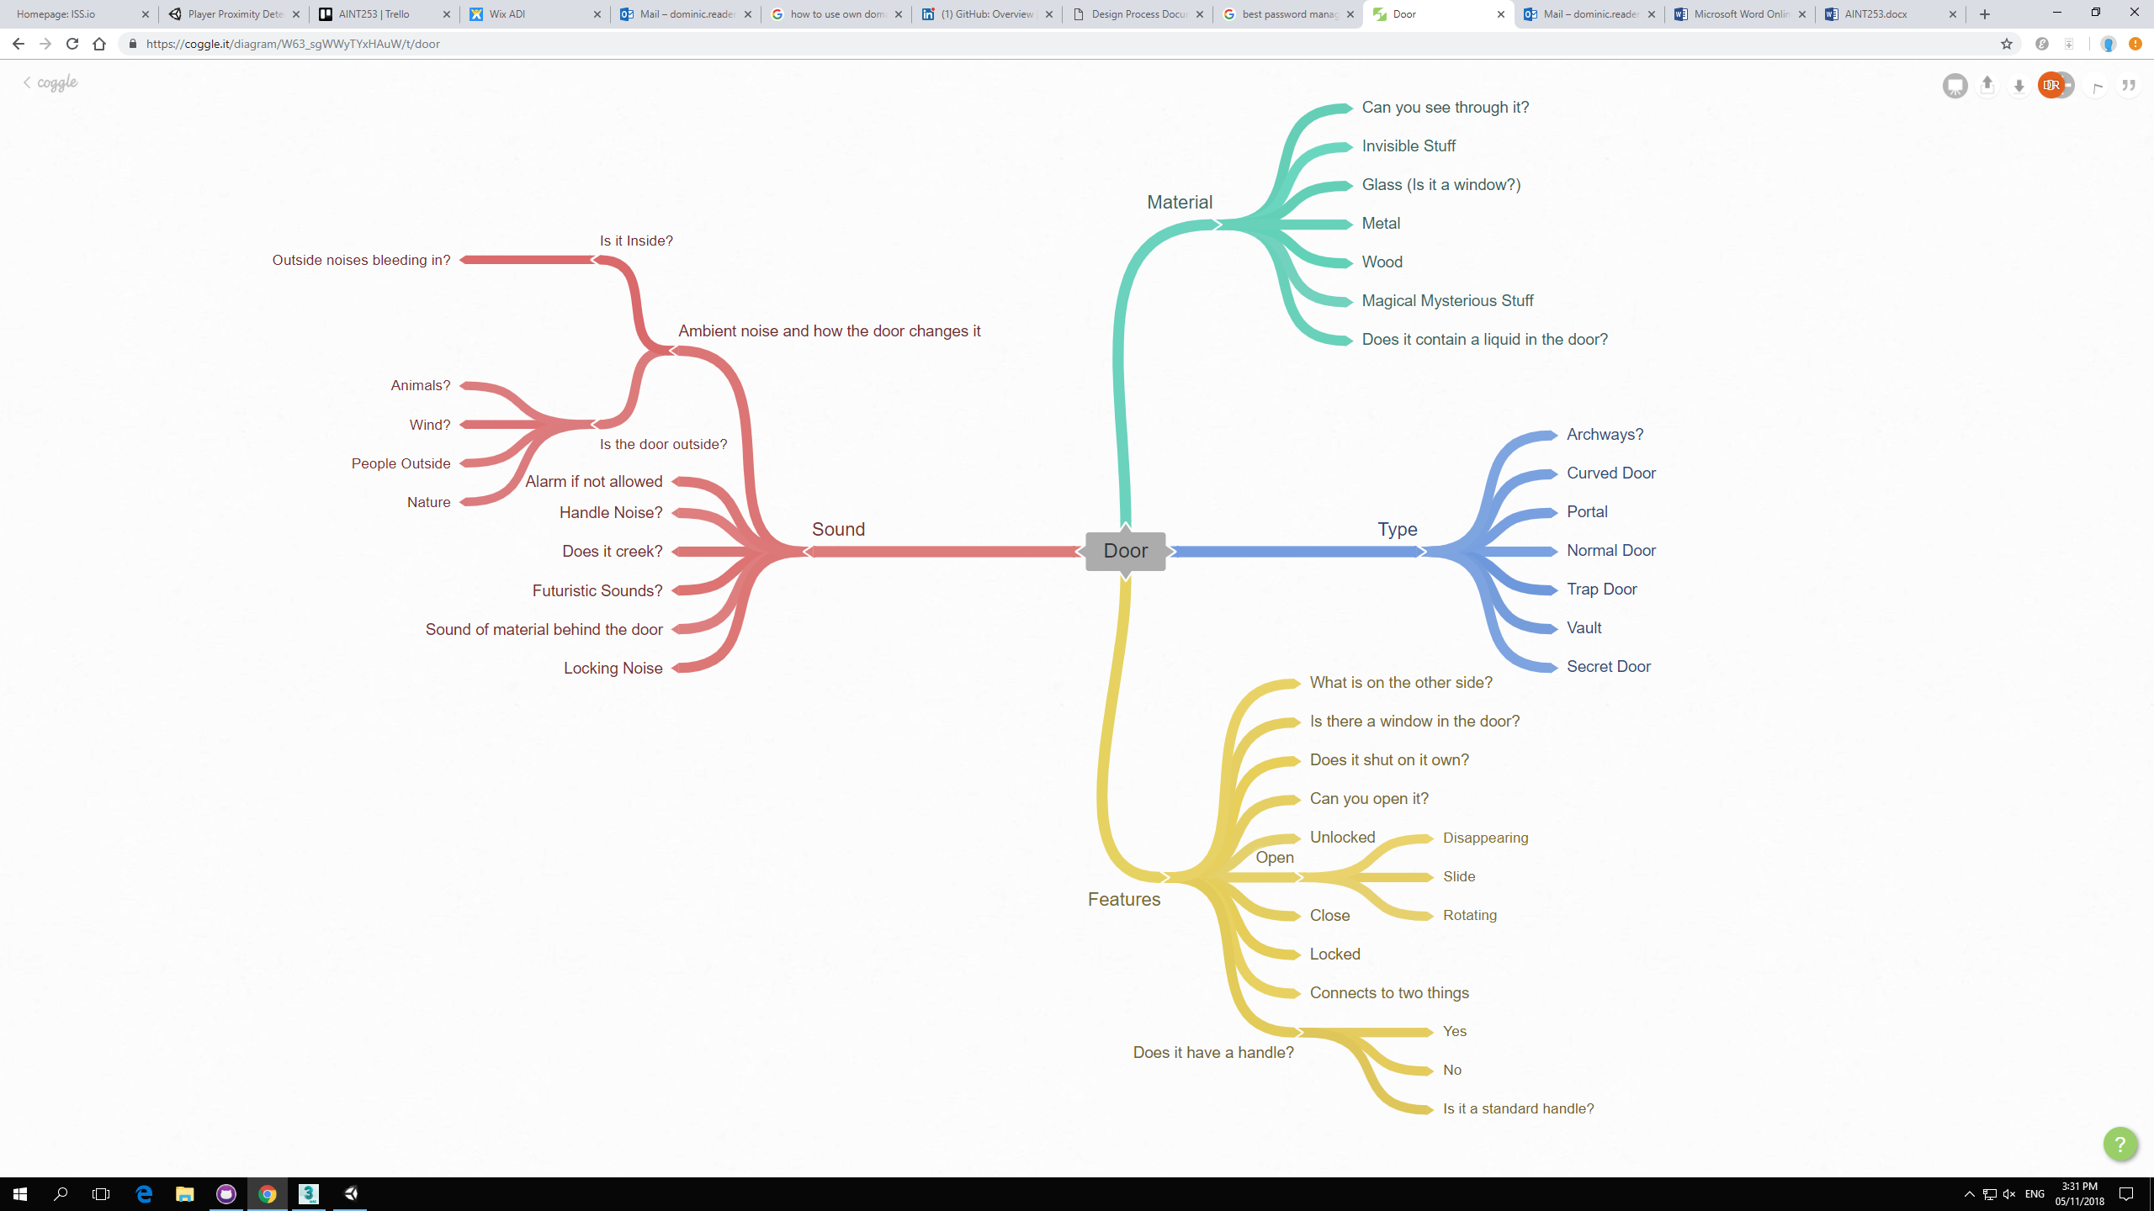

To show off the door I have put inside a scene of being on a boat below deck where the player will have to make the decision of choosing either the left or right door which will have different outcomes. This was initially designed on a User Story Map (USM)

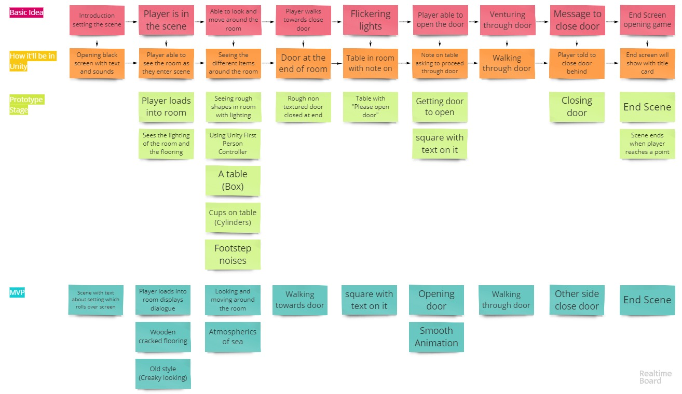

The USM above shows the process of thought and how the scene should play to show off the door project. This was the third iteration as designing the product took much thought to deliver a clean and polished product.

Link to User Story Map (<https://realtimeboard.com/app/board/o9J_kzdUFuY=/>)

Flooring and Wall Ideas

Exploring elements of the scene to set it properly proved to be incredibly important to creating a great product. One of the first elements that needed to be focused on would be the flooring of the ship as this helps generate an atmosphere that works and makes the user believe in where they are.

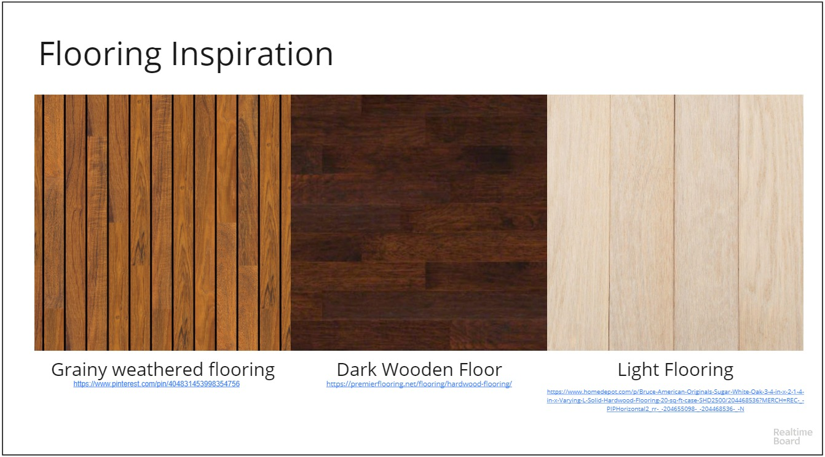

I wanted the floor to be weathered as it shows the ship has been sailing for a while and has withstood the elements that have been trying to break it down. Next would be creating the right colour to show this and it would involve a slight variation due to wear which would also make the scene more believable.

After this it was deciding on what to use for the walls as they would need to seem reinforced and strong enough to handle how rough the sea sounds outside of the ship. There were many ways to see this for example bolted wooden panels or ones with cross struts on them. The final design is based on the image below:

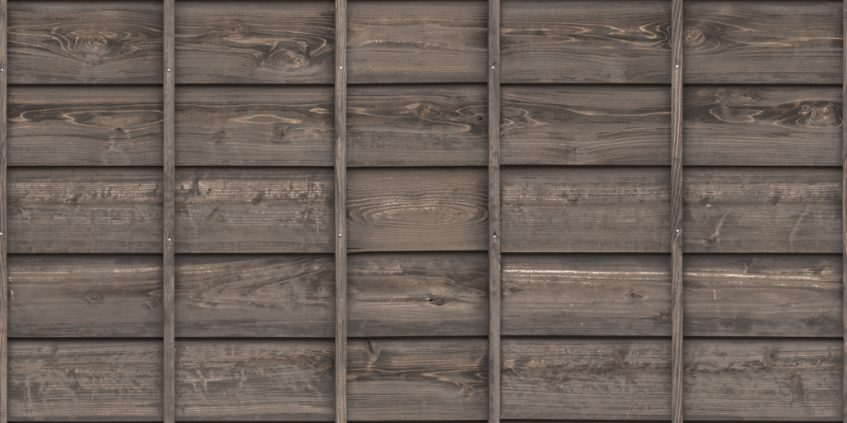

Referencing (Wooden Panel 1)

Door Ideas

My door had to both be functional at the same time as it looking smooth in its animation. It could have gone down many routes but to fit in with the theme I decided to build a ship door. Initially when I looked at the door, I decided in creating an old pirate ship style door which proved to be difficult to texture and created a look which did not fit the scene. As seen in my trello (<https://trello.com/b/9OTqynl5>) in week 2 I decided to change the theme of the door and room to be a more modern door in a steel framed ship. After changing this theme and looking at many different ship doors I decided in the end that I wanted to create a large door with individual corner locks which all had to be turned to unlock it and then open. This was done in 3DS max creating the door be chamfering the corners and extruding the wall out so that the door frame could sit properly. The locks on the door were created by drawing out a line and then creating faces and extruding them so that it resembled the correct style of door handle.